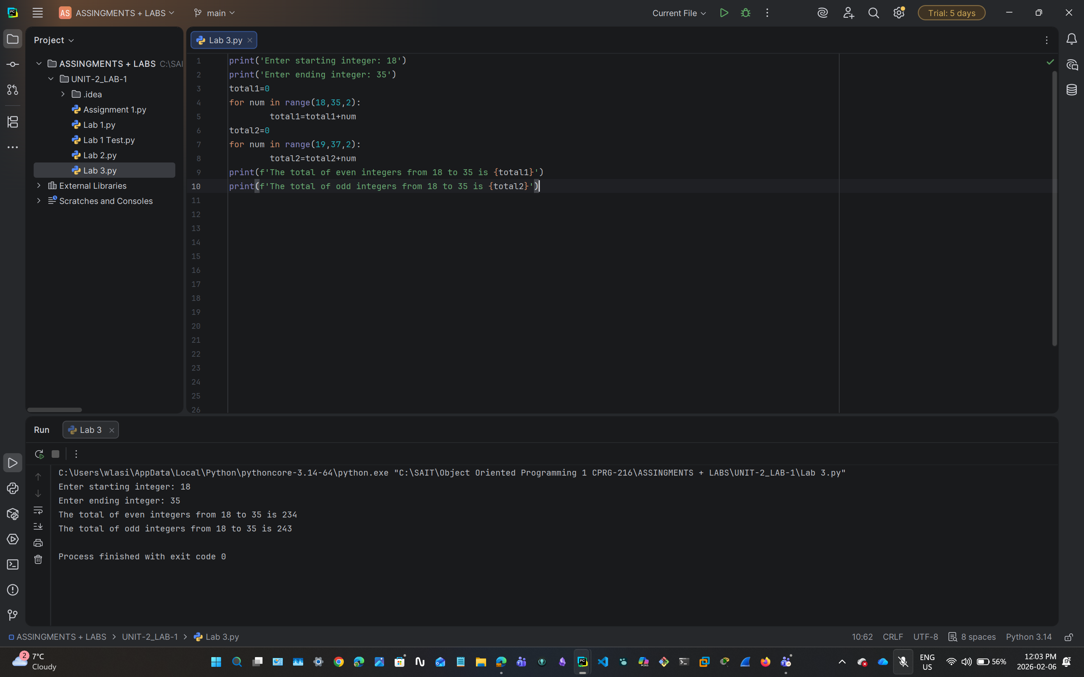

print('Enter starting integer: 18')
print('Enter ending integer: 35')
total1=0
for num in range(18,35,2):
total1=total1+num
total2=0
for num in range(19,37,2):
total2=total2+num
print(f'The total of even integers from 18 to 35 is {total1}')
print(f'The total of odd integers from 18 to 35 is {total2}')

